User Manual: Secure Multi-Client Chat System

1. Introduction
This application is a secure, multi-threaded Java chat platform. It enables multiple users to communicate in real-time while ensuring that all messages are protected by AES encryption and that only authorized users can join the network.

2. System Requirements
- Software: Java JDK 11 or higher.
- IDE: NetBeans (or any Java-compatible IDE).
- Network: Localhost environment (standard).

3. Getting Started

A. Starting the Server
- Open the project in NetBeans.
- Locate the com.chat.server package.
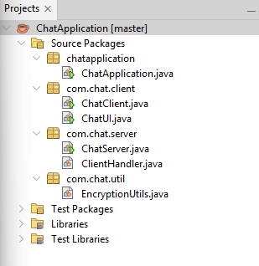
- Right-click ChatServer.java and select Run.
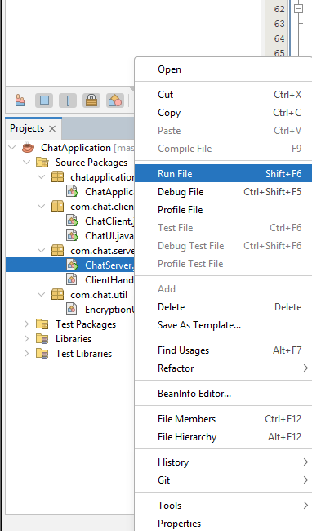

- The Output window will display: Server is actively listening on port 5000....
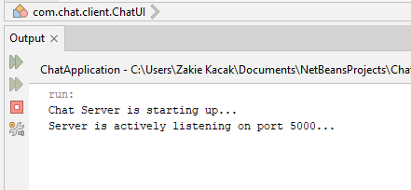
Note: Keep the server running in the background while clients are active.

B. Launching the Client
- Locate the com.chat.client package.
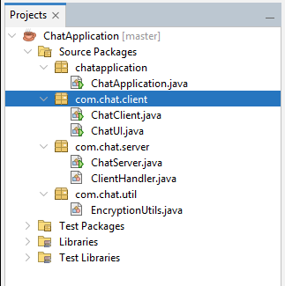
- Right-click ChatUI.java and select Run.
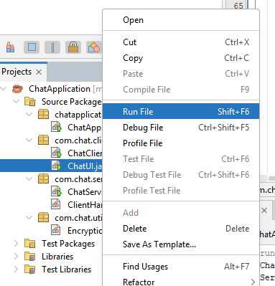

- A GUI window will appear. Repeat this step to launch as many client windows as you need to simulate multiple users.
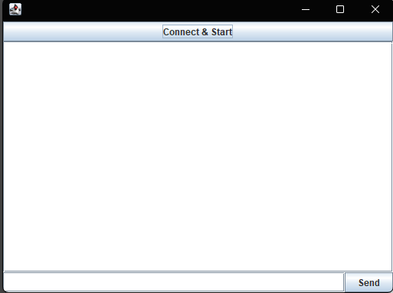

4. Operational Workflow
Once your Client GUI is open, follow these steps to begin chatting:
- Connect to Server: Click the "Connect & Start" button at the top of the client window.


- Verification: If the server is active, the chat area will display: Connected to server!.
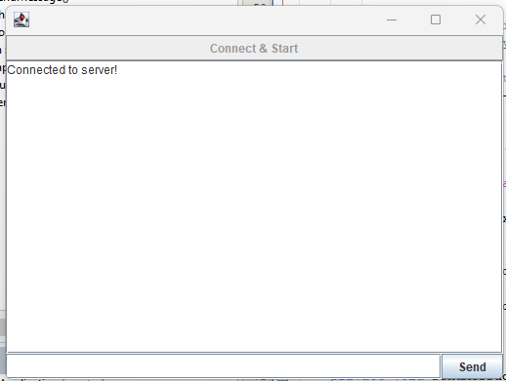
- Sending Messages:
  - Type your message in the text field at the bottom.
  - Click the "Send" button.
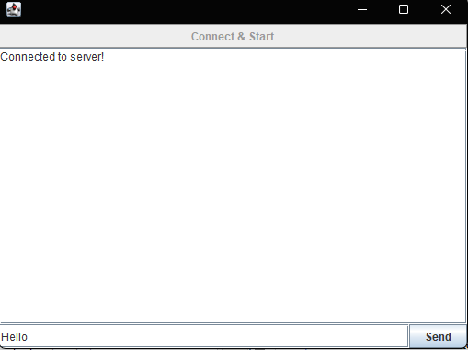
- Receiving Messages: Any message sent by a client will be encrypted by the sender, decrypted by the server for broadcasting, and displayed in the chat area of all connected clients.

5. Troubleshooting

Issue | Potential Cause | Solution
Connection Failed | Server is not running. | Ensure ChatServer.java is running before starting the client.
Message not appearing | Disconnected from server. | Check the server output to see if the client reached the server limit or had a handshake error.
Authentication Error | Incorrect handshake. | Ensure MySecretPassword is correctly configured in both the Client and Server code.

